- 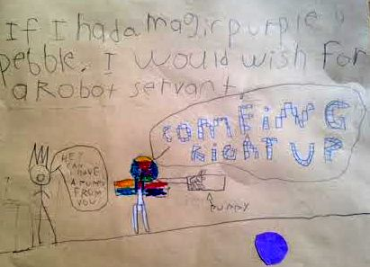
- What device wakes you up in the morning?
- No device, no alarm. My mom, she pats me awake. Sometimes, I try to take a power nap before I actually get up and go to school.

- Are you the inbox-zero type when it comes to email?
- Since I am 6 years old, I am not allowed to have my own email account.

- How do you communicate with adoring relatives who live far away?
- I Skype with them. I also have other fans and followers. They are online.

- You have a favorite website?
- Oh yes– that HAS to be scratch.mit.edu.
- I create my own games there. I put in a lot of 3D effects. They are multiplayer games, so my friend Isaac can play with me.
- You should go to my game “CAPTURE THE FLAG” and favorite it. I keep creating new ones all the time.

- I will favorite them all! Tell me, what’s one gadget you cannot live without?
- My iPad, of course. And it has to be 100% charged when you hand it to me. Not 97% or 98% -- it is just not the same thing. I don’t get mad if it’s less than 100% but…

- Hmm ... OK. How do you unplug?
- I prefer not to. But there are times when I am grounded – that means no iPad/TV/computer.

- Where do you to watch your favorite shows?
- I watch my favorite shows on television. My favorite channel is the Cartoon Network; my favorite show is Teen Titans Go. When I am grounded, I try to get my sister’s iPhone and watch my shows.

- What was the last tech tool you became a fan of?
- Amazon's Echo. Alexa – she plays my favorite songs for me.
- 1. BREAK MY MIND
- 2. FIVE NIGHTS AT FREDDY’S
- 3. ITS TIME TO DIE
- 4. IT’S ME
- I also ask Alexa some math questions: like this problem 312+312. I know the answer is 624, but I ask just to make sure.
- Sometimes I ask her stuff like “How big is your butt?” but she doesn’t answer those questions.

- What is your favorite toy?
- MIP, the balancing robot. I could control it with my dad’s cellphone. One time, I made it go right up to my neighbor’s house and knock the door. Now, the toy won’t work. We changed the battery, but it still won’t work.

- Sorry to hear that! Heard any good jokes lately?
- Oh Yes! "Yo' mama is so stupid, she went to the dentist to get a blue tooth."

- What’s on your tech wish list/what do you want Santa to bring you?
- Alexa helped me make my list for Santa. What’s on it, so far:
- XBOX1
- MIPOSAUR
- I will be adding more stuff close to Christmas.

You can check again with me later.

I would also wish for a robot servant.

